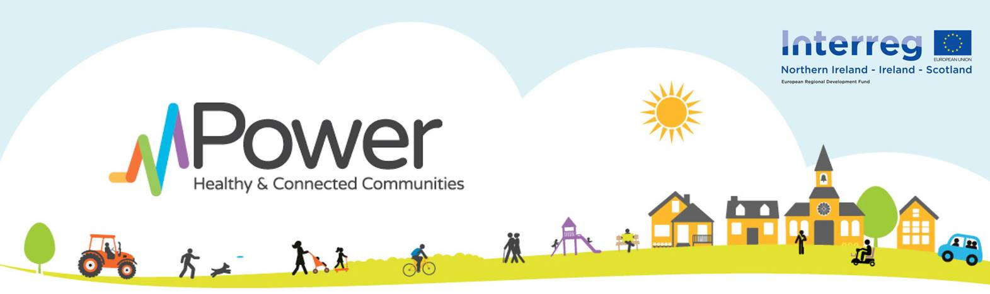
mPower Breakfast – Primary Care Engagement Event
Creating self-management opportunities for older people (65+ living with long-term conditions) in Newry City and South Armagh
7:00am – 9:00am Wednesday 17th October 2018 in Cross Square Hotel, Crossmaglen
RSVP to Marcella O’Dowd (Implementation Lead): marcella.odowd@southerntrust.hscni.net or Call: 028 3083 4207
Name _______________________ Profession ____________________ Practice Name: _____________________
Tel Number __________________ E mail ______________________

