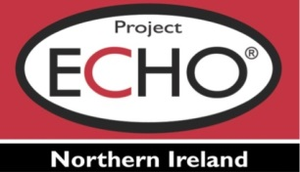
mPower ECHO Knowledge Network

Case Presentation Schedule
Year 2 – 2022

Presentation Date | Time | Case Presenters | Curriculum/Education Topic | Educator | Facilitator
Wednesday 19th January 2022 | 10.00am to 12.00pm | Claire Sharp - Jason Railton  SCVO – Digital Inclusion Development Officers | Place-based approach to digital inclusion, developing and supporting digital participation in Scotland | Claire Sharp - Jason Railton | John MacDonald & Lynn Anderson
Wednesday 16th February 2022 | 10.00am to 12.00pm | Nicola Maher | Personal Development of Project Team  (PDP/Lessons Learnt/Shared Learning) | Nicola Maher | Sue Long & Annabelle Lamont
Wednesday 16th March 2022 | 10.00am to 12.00pm | Aidan McCabe | Evaluation of mPower eHealth approaches  (ARMED / RITA) | Paul Sammons | Ewan Marshall & Anna Terje
Wednesday  13th April 2022 | 10.00am to 12.00pm | Geraldine McKnight &  Mairead McCann | MDT – Resources  / Community Digital Hubs | Aidan McCabe  Sue Long | Peter Mitchell & Nicola Maher
Wednesday 18th May 2022 | 10.00am to 12.00pm | Teresa Cawley to forward name & Aidan McCabe | Dementia services  (Dovetailing, leveraging mPower resources) | Nicola Maher -  Lynn Anderson | Teresa Cawley &Teresa McGarvey

